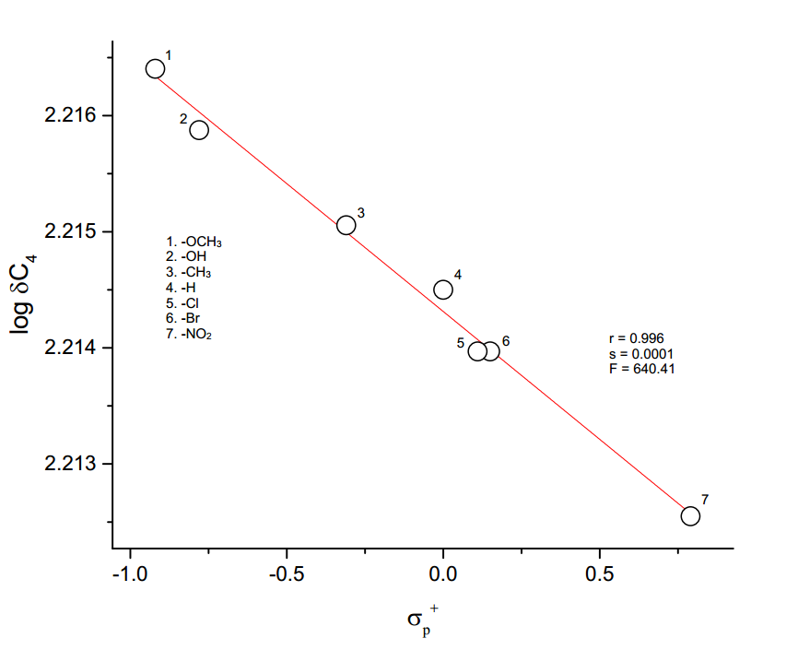

**Figure 3.8** The plot of log δC4 vs σp+